2021 AHIMA Ballot Candidate for Council for Excellence in Education
April Martin, DBA, RHIA, CHPS, CHDA, CCS, CDIP, FAHIMA
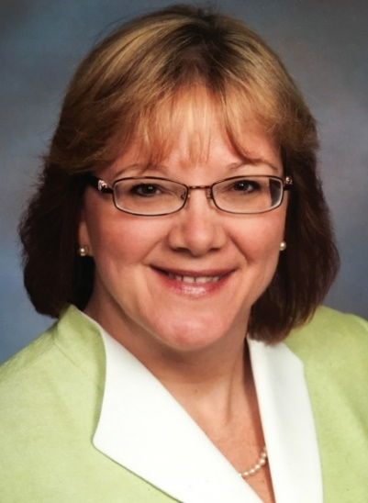
www.linkedin.com/in/april-martin-50a4b18/
ABOUT
I bring over 25 years of HIM experience to the table, comprised of both the practitioner and academic sides of our profession. I am passionate about mentoring, quality education, leading by example, and always making a difference!
EDUCATION
* Doctorate in Business Administration – DBA
Dissertation: Impact of Tacit Knowledge Deficits in Acute Care Hospital Settings
* Master’s in Strategic Leadership – MSL
Master’s project: A health information and healthcare documentation vocational
development program for inner-city youth.
* Bachelor’s in Health Information Management – BS
DEMONSTRATED HIM LEADERSHIP AND COMMITMENT TO STUDENT ADVOCACY
- HIM Director – 2015 to present
- MoHIMA Awards and Scholarship Committee – 2021
- MoHIMA Nominating Committee – 2018
- Program Director – 2012 to 2015
- Adjunct Professor – over 7 years at associate’s, bachelor’s, and master’s degree levels
- Business Owner – 2005 to 2012
- Chair of MI Medical Record Charities Annual Bowling FUNdraiser (for student scholarships) – 2009 to 2014
- Chair of MI Medical Record Charities Annual Silent Auction/MHIMA Annual Meeting Planning Committee – 2007 to 2012
- AAMT/AHDI National Director (Treasurer in 2005) – 2004 to 2006
- MAMT President-elect/President/Immediate Past President – 2001 to 2003
PROFESSIONAL CREDENTIALS
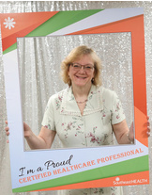
My lifetime commitment to continuous education and love of learning has led to acquisition of the following:
From AHIMA: RHIA, CHPS, CHDA, CCS, CDIP, FAHIMA
AHIMA-Approved CDI Trainer
AHIMA-Approved Revenue Cycle Trainer
From AAPC: CRC, CPCO, CPB, CIC, CANPC
From HFMA: CRCR, CSPPM
From AHDI: CMT
From HIMSS: CPHIMS
Your voice matters! You can make a difference in the future of our association by casting your vote at ahima.org/vote
Polls open July 12, 2021, at 8 a.m. CST and close July 26, 2021, at 5 p.m. CST #AHIMAElection21

